Account Creation in TRAIN Virginia
1. Go to http://www.train.org/virginia
2. Click the “Create Account” link.
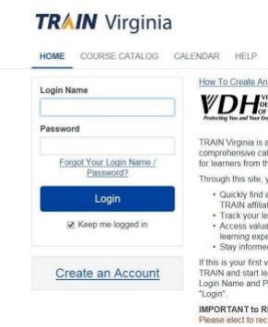
3. Fill out the required fields, check the “I agree to” box and click the “Next Step” button.
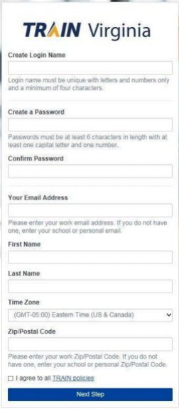
4. Click on the link to identify whether you are a Virginia certified EMS provider. If Virginia Certified EMS Provider is selected, you would fill out the following page. Then click the green button to confirm the selection.
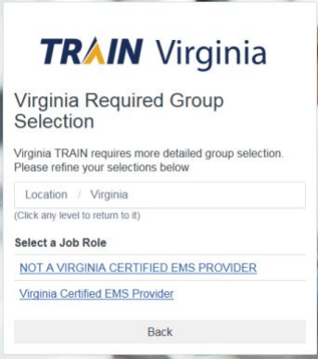5. Click the “NOT A MEMBER OF ONE OF THESE
AGENCIES/INDUSTRIES” link. Then click the green button to confirm the selection.
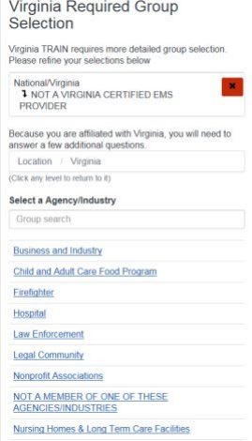6. Click one of the links to identify whether you are part of one of these groups and then click the green button confirm the selection.
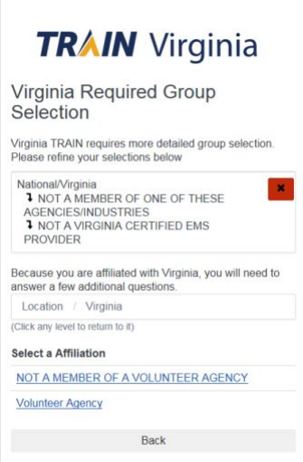7. Click one of the links to identify whether you are part of a Local Government Agency and then click the green button to confirm the selection.
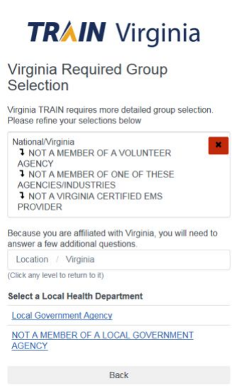8. Click one of the links to identify whether you are part of a School or University and then click the green button to confirm the selection.
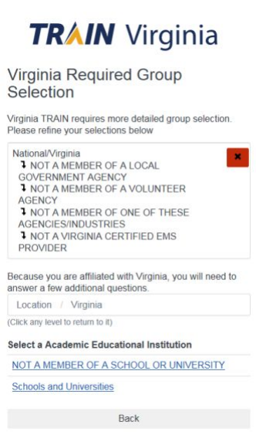9. If you belong to a state agency, click the “State Agency” link and then select the correct agency.
10. Click the green button to confirm these selections.
11. Click the “Continue” button to proceed.
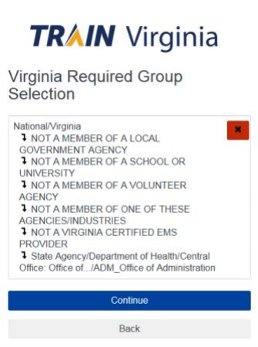12. Select whether you are a Current State Employee (Yes means STATE employee. All others select “no” including contractors,
city/county employees, volunteers and interns, industry and academia representatives.) Also, enter any other pertinent information (may not be any) and click the resulting blue “Finish Creating Account” button.

Course Registration in TRAIN Virginia

- Use the search function to enter the course ID number.
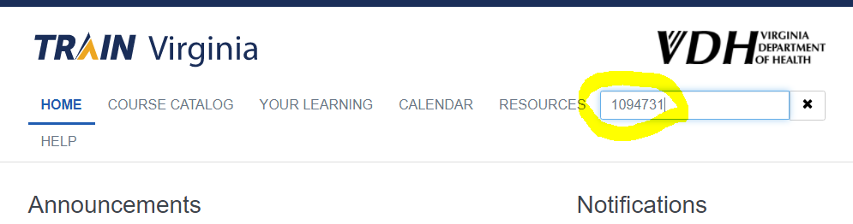

- Select the course that you want to register for.

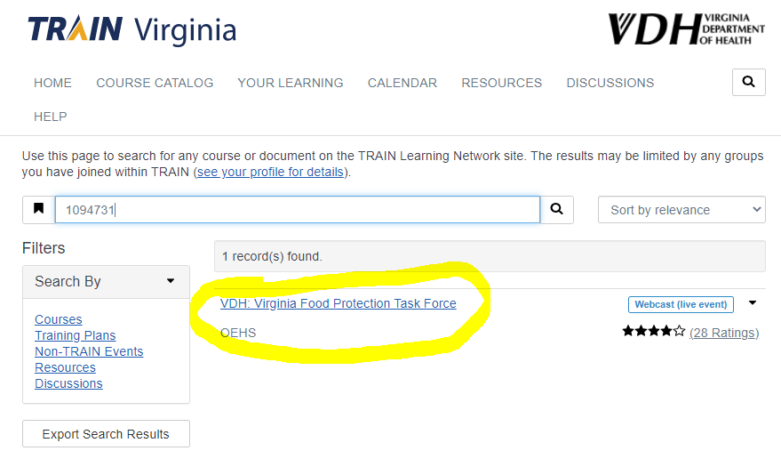

- Use the “Register” icon on the course page to register for the session.
