Georgia Food Safety & Defense
Task Force Meeting

August 2020 Virtual Meeting Agenda
Date: August 5, 2020
Time: 10:00 am – 11:30 am ET
Location: Virtual Zoom Meeting

Welcome and Intro: Jessica Badour

Stakeholder Updates
Georgia Department of Public Health: Galen Baxter, Hope Dishman
- Restaurant inspections stopped in March; routine inspections are resuming in some parts of the state.
- Environmental Health updates:
  - The division has created guidance and training videos for restaurant industry and long-term care facilities.
  - They conducted a virtual district conference.
  - FDA grant has been extended through July 2021.
- Epidemiology update:
  - Foodborne disease incidence and outbreaks have decreased.
  - One Georgia resident affected by the Cyclospora bagged salad outbreak.
  - Georgia has not yet been affected by the recent Thompson onion outbreak.
Georgia Department of Agriculture: Natalie Adan, Krissa Jones, Chris Peasley, Maggie Brown, Colby Brown, Tamsin Smith
- Legislative updates:
  - Senate Bill 345 (Save our Sandwiches) passed House and Senate.
  - Senate Bill 381 (information sharing with the FDA) passed House and Senate.
  - Senate Bill 420 (bathrooms in food sales) did not pass.
  - Senate Bill 434 (plastic bags) did not pass.
- Manufactured Food updates:
  - Resumed FDA contract inspections, with FDA permission.
  - Georgia shellfish recertification date will now expire December 31, 2020.
- Retail Food updates:
  - There are 9 openings in the retail food program; please share the openings with anyone interested.
  - The standardization process has been postponed indefinitely.
  - Field work has been phasing back in front full-time telework, focusing on complaints and backlog inspections in small stores.
  - Since the pandemic, there has been an increase in cottage food licenses and mobile vehicle food licenses.
  - Risk-based sampling program is resuming and at 35% of pre-COVID capacity.
- Produce Safety Program:
  - On Farm Readiness Reviews and inspections have resumed.
  - Program is slowly trying to open Produce Safety Growing training again.
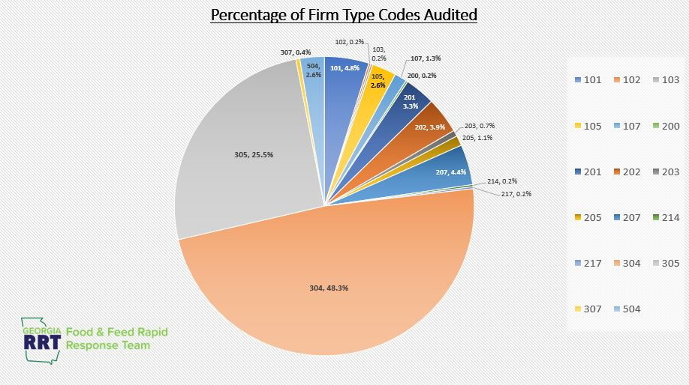
- RRT updates:

  - From December 1, there have been 32 complaints regarding COVID response.
  - GDA has ensured the distribution of over 250,000 face masks.
  - From January to March 2020 the GDA removed 206 units of product during a recall audit check. The largest problems were in store codes 304 and 305 (convenience stores and delis).
- Emergency Management updates:
  - PowerPoint Slides: Sims Updates .pdf
  - COVID communication plan is focusing on building resilience.
  - Crisis Counseling Program will serve food, agriculture, and hospitality workers, as well as the general public.
    - If you are interested in helping with a Crisis Counseling app, please contact Venessa Sims at Venessa.sims@agr.georgia.gov.
  - Georgia Grown To-Go pop-up markets have been a success and will continue into the fall.
  - GDA is now preparing for hurricane season, with COVID precautions.
FDA: Cameron Wiggins
- Office of State Cooperative Programs Retail Food update:
  - National retail food team will not be conducting new and re-standardizations of field officers.
  - Expiration dates are extended; maintenance dates are extended through 2020.
  - OSCP is partnering with NEHA to host the 2020 Food Retail Safety Seminar.
    - Register here.
  - OSCP is working on Democratic and Republican National Conventions.
  - For FDA COVID information:
    - FDA’s food and cosmetic information center Inquiry Page
    - FDA’s latest COVID information: Coronavirus Disease 2019 (COVID-19)
- Half East 3 updates:
  - The office lifted the state stop work order and actively working on FY 21 adjustments.
  - FDA has resumed prioritized domestic surveillance inspections based on local COVID rates.
USDA: Kenneth Cash
- Most in the USDA are teleworking but the offices are open.
- Investigators had to move online and work regulatory positions.
  - This has impacted production of proteins.
- Complaints have gone up and the USDA is working to address them.
- Offices of public health and science are still working, and will assist when needed.
CDC: Dr. Art Liang
- CDC scaled up food-related guidance through the pandemic.
- Food systems work group in the EOC response is working actively with National Restaurant Association.
- The CDC is looking for any feedback. You can reach out to the FSTF and we will bring this to the CDC.
Georgia Fruit and Vegetable Growers Association: Beth Oleson
- Food safety consulting and education arm is now nationwide.
  - The program includes farm visits, packing facilities, consulting, and trainings.
- Reach out the Beth if you know someone who can benefit from a cost-share program for food-safety consulting and audit fee.
- Southeast Regional Fruit and Vegetable Conference is considering virtual or in-person conference this year.
- Planning is underway for the Food Safety Educational Conference for farmers, packing, owners, and managers.
Georgia Food Bank Association: Callie Roan
- Since COVID, the food banks have seen 30-40% increase, up to 60% in some areas.
- The food banks have served 4.2 million meals per week since pandemic.
- In the near future, they expect to distribute 400,000+ boxes of produce, meat, with milk.
- There is a problem of loss of volunteers, but the food banks have received National Guard Assistance.
- The food banks expect to see sustained demand for food assistance and an increased burden to feed people directly.
- There was an appeal to Congress for 15% increase in SNAP benefits.
- The banks are looking to increase cold storage.
Georgia Restaurants Association: Karen Bremer
- The GRA has been working with the CDC and DPH to update guidance.
- Restaurants have lost more jobs and revenue than any other industry and will be the slowest to recover.
  - Restaurant unemployment jumped to 39.3% in April; it is currently to 28.9%.
  - Restaurants have lost $145 billion in revenue so far.
- A new initiative is the Georgia safety promise: trade associations came together to regain trust and make a pledge with safety measures.
- THRIVE Georgia is training employees on COVID safety measures.
- Atlanta Family Meal is providing meals for restaurant workers and their families.
- Right now, the GRA is working on a temporary order for curbside mixed drinks and asking to prioritize restaurant workers in COVID antibody testing.
Georgia Tech: Wendy White
- The GT MEP is continuing to offer professional development, classes, third party consultations, gap assessments, and compliance.
- The MEP is developing employee protection guidance and business continuity guidelines.
- The Georgia Regulatory Breakfast Event is rescheduled for Nov. 5, 2020.
  - Register here.
University of Georgia: Tori Stivers
- Seafood HASSAP is conducting operations virtually.
- NOA is funding seafood response, which will involve asking 7-10 processors on their adaptations.
- You can sign up for free classes at GeorgiaSBDC.org.
  - Webinars will be starting in Aug, June 2021, so check the site for updates soon.
University of Georgia Extension: Elizabeth Andress
- ServSafe and trainings can be given virtually, but are waiting due to regulations.
- Extension is now allowed to proctor certified exams; tests can be proctor print or online tests in person with social distancing.
- Educators are doing zoom programs; home food preservation has been very popular.
  - There is no means of tracking, but keep this in mind for rise in botulism and food waste.

Action Items
- If you are interested in helping with a Crisis Counseling app, please contact Venessa Sims at Venessa.sims@agr.georgia.gov.
  - OSCP is partnering with NEHA to host the 2020 Food Retail Safety Seminar.
- Register here for the FDA and NEHA’s Digital Defense Conference.
  - The conference is free and will be held on August 18 and 19.
- Reach out to the FSTF at Jessica.badour@agr.georgia.gov with any feedback on food-related response for the CDC.
- Beth Oleson is taking ideas/speakers for Food Safety educational conference with the audience focusing on produce growers, packers, and shippers: boleson@asginfo.net
- You can sign up for free classes at GeorgiaSBDC.org, starting August 21.
- Reach out to Tori Stivers, Seafood Specialist at tstivers@uga.edu ; 770-460-2506 for trainings.

